Work-Life Balance Workshop
Having a balance between work and home life can be a challenge. With this challenge come great rewards when it is done successfully. By balancing a career with home life it will provide benefits in each environment. You will become healthier, mentally and physically, and you will be able to produce more career wise.
With a Work-Life Balance you will be managing your time better. Better time management will benefit all aspects of life; you will be working less and producing more. This workshop will show how to focus on the important things, set accurate and achievable goals, and communicate better with your peers at work and your family at home.
Workshop Objectives:

- Explain the benefits of work life balance.
- Recognize the signs of an unbalanced life.
- Identify employer resources for a balanced lifestyle.
- Improve time management and goal setting.
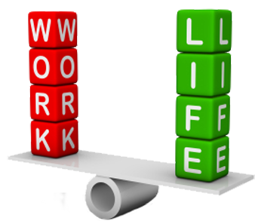
- Use the most effective work methods for you.
- Create balance at work and at home.
- Manage stress.
Native Education & Training College
www.nativetc.com

